Auckland PSITM Institute
Registration form for PSI Seminar
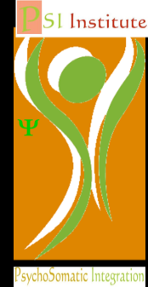
Name Street Address _________

Suburb City Work Phone _________________

Mobile Phone Home Phone __ __________

Email Address Professional Discipline ____

REGISTRATION FEES

Please tick ONE of the boxes below to indicate scheduling preference & circle amount of payment:

DATES AND TIMES | GROUP | COST | Tick
Monthly Mondays 5 August through 2 December 10:30 am – 3:00 pm includes half hour lunch break (Dates: 5 August; 2 Sept; 14 Oct; 4 Nov; 2 Dec; meets 2 hours on the last class 2 December from 11 am – 1 pm)  Early Payment Fee (received before 15 July) $540  If received after 15 July pay $580 | PSI Seminar A | $540/ $580
Monthly Tuesdays 9:30 am – 2:00 pm 6 August through 3 December includes a half hour lunch break (Dates:6 August; 3 Sept; 15 Oct; 5 Nov; 3 Dec; meets 2 hours on the last class 3 December from 11:30 am – 1:30 pm)  Early Payment Fee (received before 15 July) $540  If received after 15 July pay $580 | PSI Seminar B | $540/ $580

Payment Submitted/Enclosed*

$______________________________

*All fees are in NZD. Payments may be transferred directly into account #02-1206-0033961-000
Please return form by email to jlightstone@gmail.com or post with cheque made out to
Judy Lightstone, 26/457 Swanson Rd., Ranui, Auckland 0612

Venue Details
Auckland PSI Institute, 254 Lincoln Road, Henderson. Map and directions available here: http://www.psychotherapist.org/mapanddirections.htm

